**Pattern Searching | C++ Foundation**

iven a text of length **N** txt[0..N-1]and a pattern of length M pat[0..M-1], write a function search(char pat[], char txt[]) that prints all occurrences of pat[]in txt[]. You may assume that N>M.  
**Examples:**

***Input:****txt[] = “THIS IS A TEST TEXT”, pat[] = “TEST”*  
***Output:****Pattern found at index 10*

***Input:****txt[] =  “AABAACAADAABAABA”, pat[] =  “AABA”*  
***Output:****Pattern found at index 0, Pattern found at index 9, Pattern found at index 12*

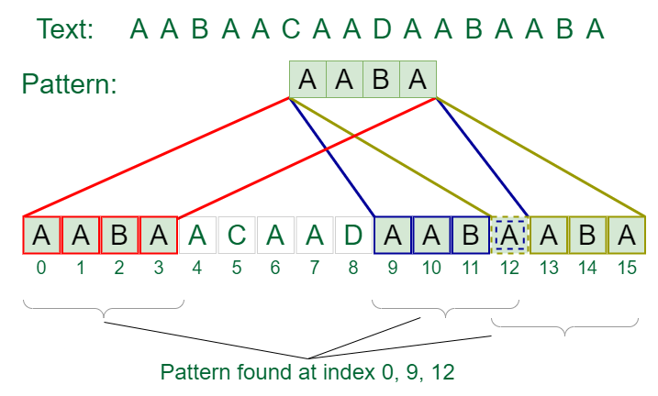

C++

#include<iostream>

using namespace std;

void printIndex(string text, string pat)

{

int found = text.find(pat);

while(found != string::npos)

{

cout << "Pattern found at " << found << '\n';

found = text.find(pat, found+1);

}

}

int main()

{

string text, pat;

cin >> text >> pat;

printIndex(text, pat);

return 0;

}

**Output**

Pattern found at 0